Emergency Evacuation Plan

The setting is separated across two floors (Ground Floor & First Floor). The Ground Floor is separated into 5 areas noted below:

- The main room (including open plan kitchen),
- The baby room,
- Children’s toilet,
- Adult/disabled toilet, and
- Staff office

The area considered to be the first floor is separated into 5 areas:

- Reception entrance (including disabled toilet)
- The main room (including staff kitchen)
- The kitchen/dining room
- Toilet
- Sensory and back playroom

The ground floor can be evacuated through three entrance/exit points, of which all are emergency exits. Figure 1 below illustrates the internal arrangements and exit points of this setting:

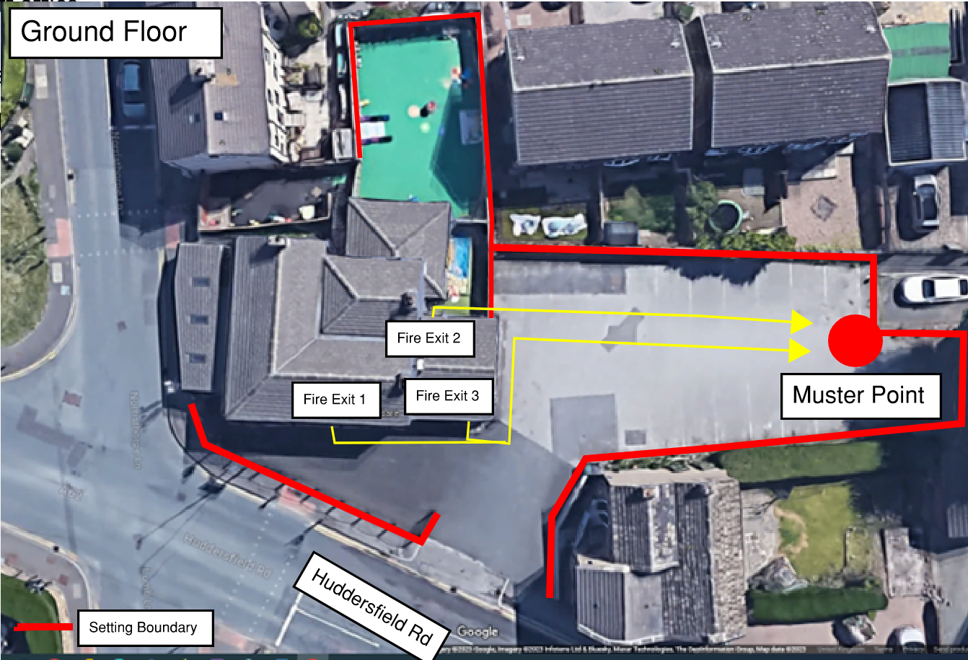
Figure 1 – Ground Floor Emergency Exit Points

The first floor can be evacuated through two entrance/exit points, of which all are emergency exits. Figure 2 below illustrates the internal arrangements and exit points of this setting:
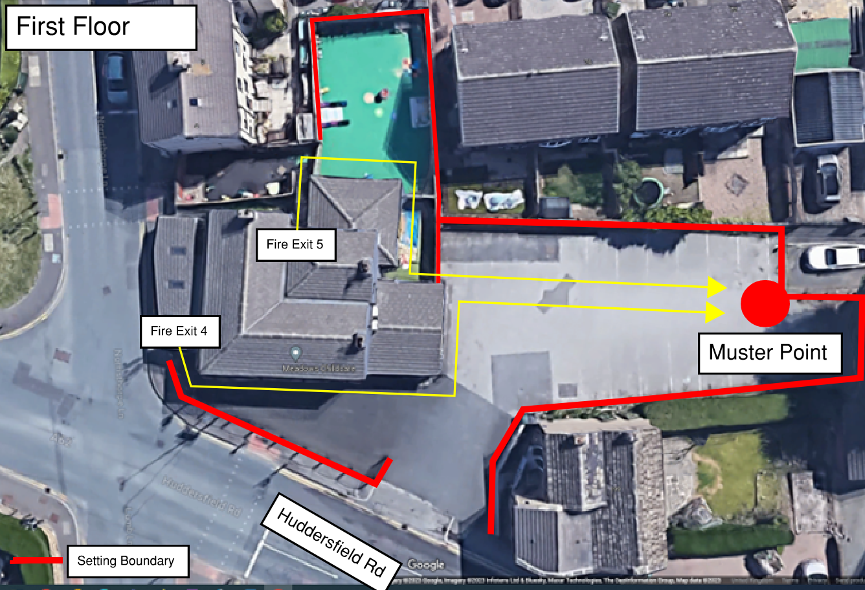
Figure 2 – First Floor Emergency Exit Points

In the event of an emergency, all children and staff will be evacuated via the relevant emergency exit point and gather at the Muster Point in the adjacent car park.

Staff will select the most appropriate exit in the event of an emergency. Once all staff and children are safely gathered at the Muster Point, staff will raise the alarm through calling 999. However, these are the most likely exists to be used on a typical nursery day:
Emergency Exit Number | Room
Exit 1 | Main room: Lower pre-school and kitchen
Exit 2 | Baby room, Under 2 Room & Toilets
Exit 3 | Baby room
Exit 4 | First Floor Reception & Main room (including staff kitchen)
Exit 5 | Kitchen Diner, Toilet, Sensory & Back-play rooms

Staff and children will only re-enter the building once confirmation that the building is safe to enter has been granted by the emergency services.

Emergency Evacuation Procedure

The setting will ensure all staff understand the emergency evacuation procedure should we ever experience an emergency such as a fire, flood, power cut, gas, bomb scare or terrorist attack. Staff are kept up to date with fire prevention methods and have current paediatric first aid training. The fire evacuation plan is located on the main notice board; we practice evacuation drills regularly. These drills take place on different days to ensure all children get to know this procedure and are not afraid of the alarm sounding. This is then recorded in a log book detailing what/where ‘the emergency’ took place, how we exited the building, which children were in for the drill, the duration and any problem that occurred.

In the event that the building cannot be re-entered, and childcare provision cannot be provided, then all parents/carers will be contacted to collect their children. Whilst staff/children are awaiting parents/carers children will be kept safe and warm with blankets and waterproof sheets, if needed.

If we have a gas/ explosion evacuation then the children will be taken an appropriate distance from the building through the bottom of the car park, past the bollards and onto the private lane.

If we have to evacuate the building due to a flood or power cut and cannot continue providing childcare this day, the parents/carers will be called immediately.

We are aware of the Jo Cox terrorist incident that happened in the nearby town of Birstall (2016). As part of our emergency policy, we are including this kind of terrorist attacks that could possibly happen near our nursery. In this situation we would lock down the nursery. This means we would lock all windows and doors, close the blinds and would then calmly move the children away from any windows/exits. We would aim to keep the children calm and notify the police of the situation and follow their instructions. As part of our lockdown policy, we would not open our doors until the situation has been made safe and the police have given instructions for us to do so. Therefore, this means we would not be able to open the door to parents while the situation is ongoing. Parents would need to remain safely away from the nursery until the situation was made safe.

